ILYUBAYEV ALI
Task A
Task A — Anatomy of a Real Webpage

I examined the LANGAME page dedicated to PRIME GAME HUB, as it resembles our TOP GAME project.

Document information:

* Doctype: `<!DOCTYPE html>`
* Language: `lang="ru"`
* Encoding: `UTF-8`
* Viewport: `width=device-width, initial-scale=1.0`
* Title: `PRIME GAME HUB Computer Club Astana`
* Meta tags: `description`, `og:title`, and `og:description`

The page contains a header, navigation, a main heading, an image of the club, information on services and prices, a table of equipment specifications, a location map, reviews, contact details, forms, and a footer. Headings and lists are used; however, many structural blocks are implemented using `div` elements.

The equipment table presents specifications for computers in various gaming zones. The contact form includes fields for name, email, phone number, and a message, as well as a consent checkbox and a submit button.

I identified three structural issues. First, generic `div` elements are used for important content groups, whereas our pages utilize `section`, `article`, and `aside`. Second, the equipment table lacks a clearly defined visible heading; our table uses `caption`, `thead`, and `tbody` elements, along with the `scope` attribute. Third, some form elements may lack explicitly associated `label` elements; in the `booking.html` file, the `for` attribute value of each label matches the `id` of the corresponding field.
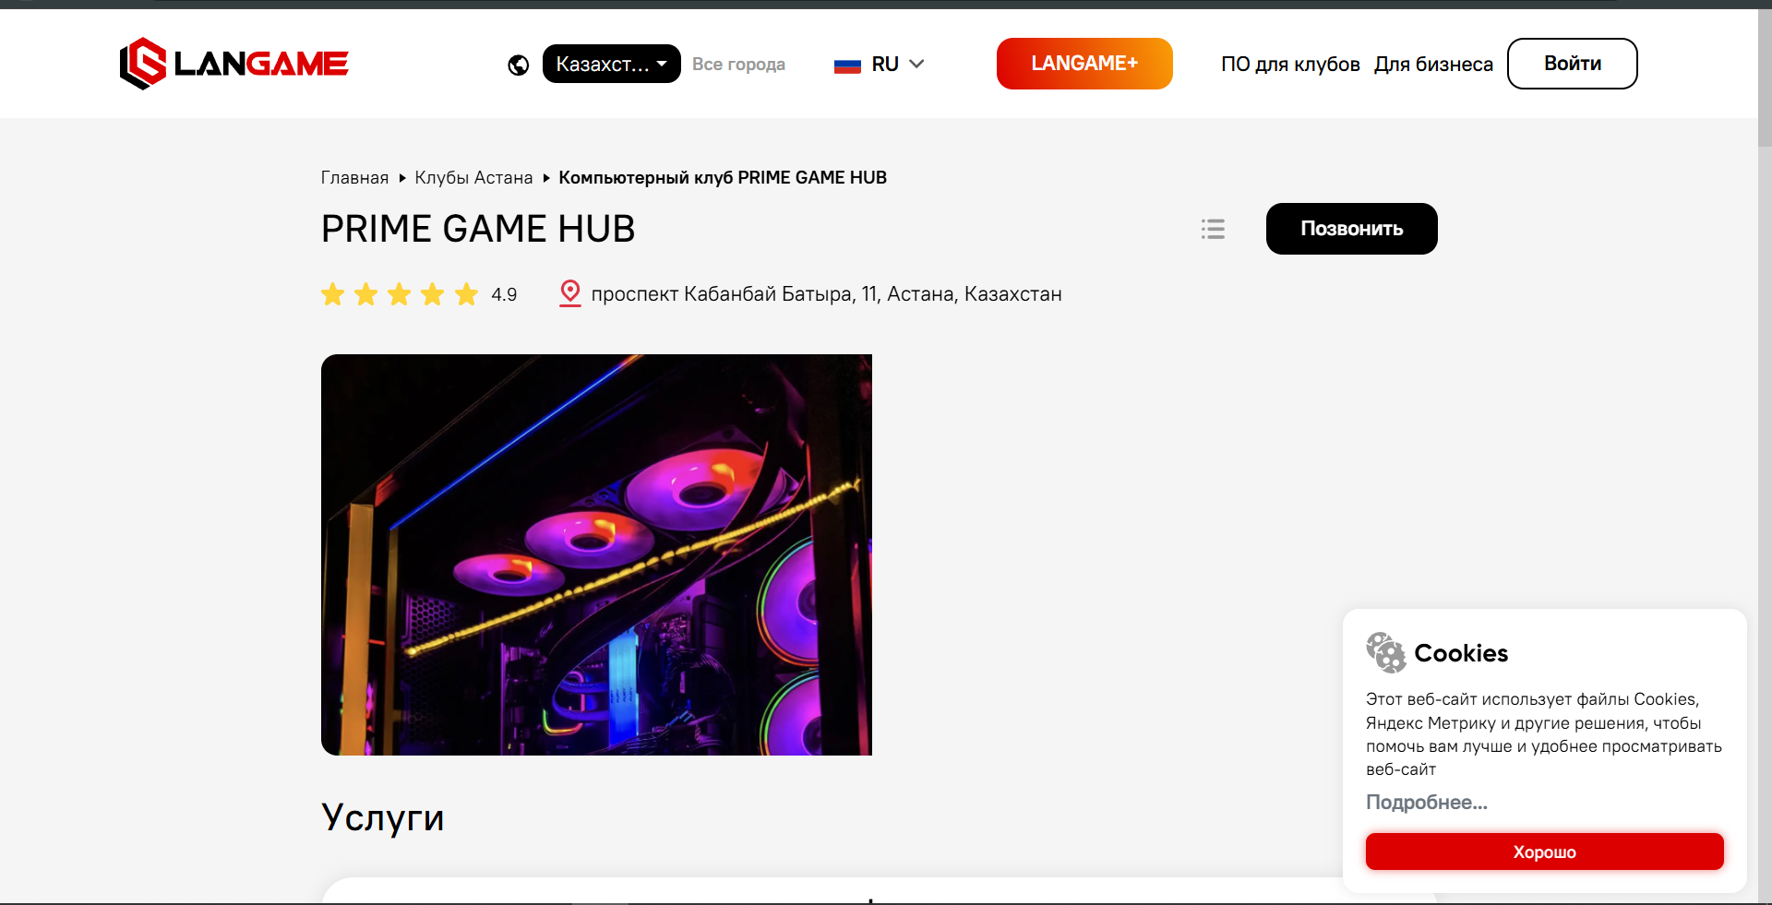
Task B
A web page is an HTML document composed of elements, content, and attributes. In my "TOP GAME" project, the `<head>` section contains technical information: the title, character encoding, description, author details, and viewport settings. The `<body>` section includes visible elements: headings, paragraphs, navigation links, images, contact details, and a booking form.

When the browser opens one of my files, it reads the markup, recognizes tags and attributes, constructs a structured representation of the page, and displays the content on the screen. Since the project lacks CSS styles, the browser uses its default visual settings.

I chose to use semantic elements instead of the generic `<div>` in three instances. On the `about.html` page, I used `<section id="club-space">` because the description of the gaming areas constitutes a distinct thematic section with its own heading. On the `booking.html` page, I used `<aside id="direct-contact">` because the phone number, address, and opening hours complement the booking form but are not its primary content. On the `colophon.html` page, I selected the `<article>` tag for the HTML code example, as it represents a self-contained snippet that makes sense independently of the surrounding text.

Currently, when the submit button is clicked, the browser first validates the required fields. If the data is valid, the form attempts to submit it using the POST method. However, since there is no server-side handler, no actual booking request is created or sent to the administrator. 